Figure Skating Log Transformation Solutions
Figure skating is a sport where people perform routines on ice to music, combining athletic skill with artistic expression. Skaters compete in different categories like men’s singles, women’s singles, pairs (a man and a woman skating together), and ice dance (which focuses more on rhythm and movement). Each skater or team performs two routines: the short program and the free skate. The short program is a shorter routine with a list of required moves that every skater must include. Judges look at how well each move is done and how smoothly everything fits with the music. The free skate is longer and gives skaters more freedom to show their personal style and creativity. They still need to include certain types of moves, but they can choose how to put them together. Judges give scores for both routines based on how difficult the moves are, how well they’re done, and how artistic the performance is. The scores from both routines are added together, and the skater or team with the highest total wins.
Read in the Dataset:
library(readr)
library(ggplot2)
library(tidyverse)
library(rvest)
library(here)
library(dplyr)
Skating <- read_csv(here::here("C:/Users/0211f/GitHub/slu_score_module_development/frhinehart/Olympic Figure Skating/logTransformation/Module/MensFigureSkating.csv"))
Question 1:
- Fit a model that uses year to predict total points (TP). Write the fitted model below using the model summary output.
skating_mod1 = lm(TP ~ Year, data = Skating)
summary(skating_mod1)
Call:
lm(formula = TP ~ Year, data = Skating)
Residuals:
Min 1Q Median 3Q Max
-88.258 -20.431 0.412 19.744 72.079
Coefficients:
Estimate Std. Error t value Pr(>|t|)
(Intercept) -8594.3305 1010.0458 -8.509 6.46e-14 ***
Year 4.3806 0.5015 8.735 1.92e-14 ***
---
Signif. codes: 0 '***' 0.001 '**' 0.01 '*' 0.05 '.' 0.1 ' ' 1
Residual standard error: 31.08 on 118 degrees of freedom
Multiple R-squared: 0.3927, Adjusted R-squared: 0.3875
F-statistic: 76.3 on 1 and 118 DF, p-value: 1.923e-14
$$\hat{TP}=−8594.3305+4.3806×Year$$
- Provide an interpretation of the intercept of the model.
The intercept is -8594.3305 which means that when the year is zero the estimated total points is -8594.3305.
- Plot the model on a scatterplot and add a smoother. Comment on any trends you see on the graph.
ggplot(data = Skating, aes(x = Year, y = TP)) +
geom_point()+
geom_smooth(method ="loess", se = FALSE)
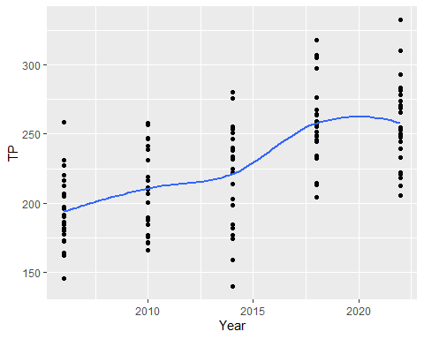
According to the smoother, the total points tend to increase as years increase and leveling off in 2022.
Question 2:
Consider the new variable “YearsSince2006” which tell us how many years since 2006. Use the internet to determine what is special about the number used to create the new variable? What would be an interpretation of the new variable? Would you rather create the new variable by subtracting mean(Year)? Why or why not? Create this new variable in your dataset.
Skating2 <- Skating |>
mutate(YearsSince2006 = Year - 2006)
The number is the year when the new international point system was introduced. Scores are calculated based on difficulty and execution of each maneuver instead of the previous 6.0 scale in order to promote more of a fair judging system.
Subtracting mean(Year) would center the data around zero, making the average year equal to zero. This does not provide the same understanding of changes relative to after the shift in point system. Using 2006 as a reference point offers a meaningful baseline for analyzing trends and changes in the sport after the new judging system implementation.
Question 3: Fit a model that uses the new variable created above to predict TP. Provide an interpretation of the intercept of the model.
skating_mod2 = lm(TP ~ YearsSince2006, data = Skating2)
summary(skating_mod2)
Call:
lm(formula = TP ~ YearsSince2006, data = Skating2)
Residuals:
Min 1Q Median 3Q Max
-88.258 -20.431 0.412 19.744 72.079
Coefficients:
Estimate Std. Error t value Pr(>|t|)
(Intercept) 193.2033 4.9138 39.319 < 2e-16 ***
YearsSince2006 4.3806 0.5015 8.735 1.92e-14 ***
---
Signif. codes: 0 '***' 0.001 '**' 0.01 '*' 0.05 '.' 0.1 ' ' 1
Residual standard error: 31.08 on 118 degrees of freedom
Multiple R-squared: 0.3927, Adjusted R-squared: 0.3875
F-statistic: 76.3 on 1 and 118 DF, p-value: 1.923e-14
193.2033 is the intercept which means that in 2006 the estimated total points is 193.2033.
Question 4:
- Fit a model that uses SP (Short program) to predict FS (Free Skating). Comment on the 4 model assumptions and if applicable, provide relevant plots to support your answer.
model <- lm(SP ~ FS, data = Skating2)
plot(model)
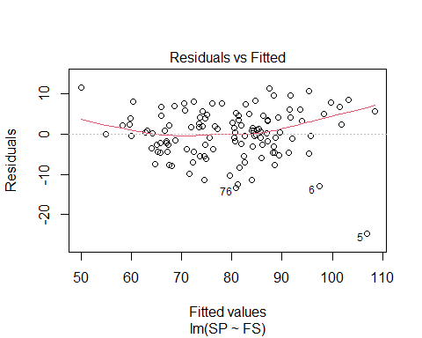
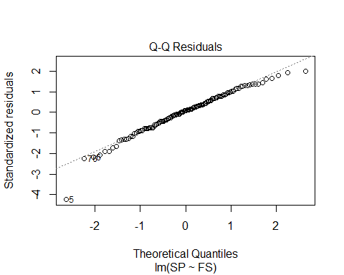
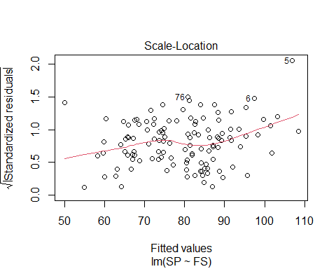
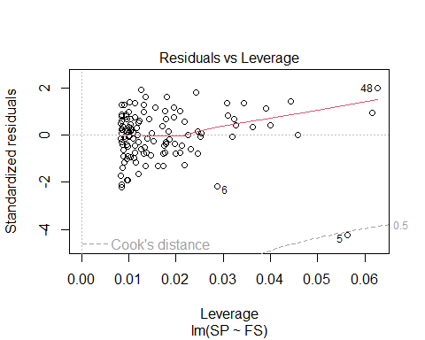
- Normal - No because there is significant amount of points that deviate from the fitted line on the qq plot (specifically the tails)
- Independent - Yes. We can assume the data was collected randomly and independent from each other.
- Constant Variance - No because The residuals seem to be fanning outward towards the middle on the residual vs fitted plot
- Linearity - No, there is a curve in the data points on the residual vs fitted
- Based on the answers in part a what transformation should you preform on what variable?
A log transformation on the y variable
- Preform a the transformation on and write down the fitted model below using the model summary output.
model_log <- lm(log(SP) ~ FS, data = Skating2)
summary(model_log)
Call:
lm(formula = log(SP) ~ FS, data = Skating2)
Residuals:
Min 1Q Median 3Q Max
-0.29821 -0.04579 0.00703 0.04958 0.13106
Coefficients:
Estimate Std. Error t value Pr(>|t|)
(Intercept) 3.5791561 0.0375035 95.44 <2e-16 ***
FS 0.0052495 0.0002477 21.20 <2e-16 ***
---
Signif. codes: 0 '***' 0.001 '**' 0.01 '*' 0.05 '.' 0.1 ' ' 1
Residual standard error: 0.07487 on 118 degrees of freedom
Multiple R-squared: 0.792, Adjusted R-squared: 0.7902
F-statistic: 449.3 on 1 and 118 DF, p-value: < 2.2e-16
$$\hat{FS}=e^{3.591561}×e^{.0052495SP}$$
d) Interpret Beta_0 and Beta_1.
Beta_0 - The predicted FS when SP = 0 is e^3.591561
Beta_1 - For each one-unit increase in SP, the predicted FS increases by a factor of e^.0052495

